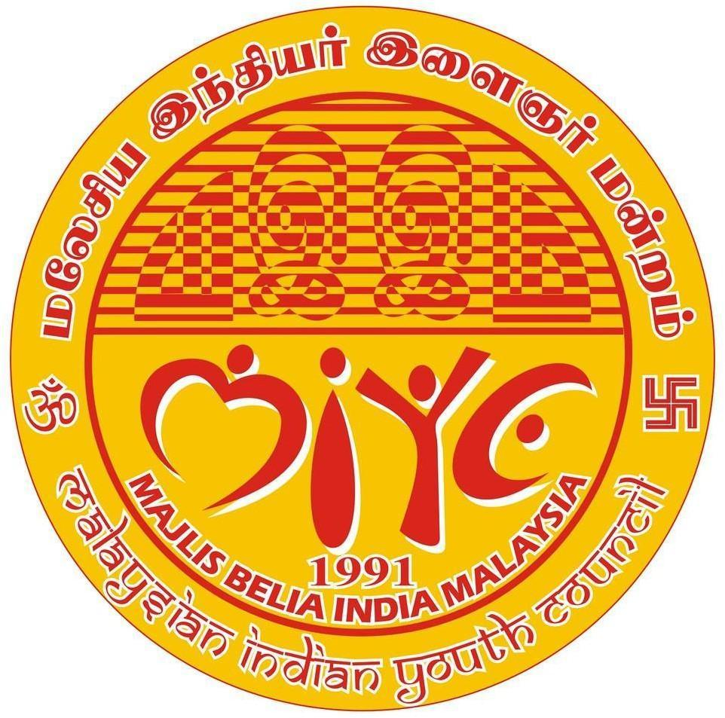
Malaysian Indian Youth Council (MIYC) Majlis Belia India Malaysia
No. 87, 2, Jln SBC 1, Taman Sri Batu Caves, 68100, Selangor, Malaysia
19-08-2025

The Control (Travel) Officer
Department of Immigration & Emigration Sri Lanka
Dear Sir/Madam,

Subject: Urgent Request for Passport Release

I am writing to request the urgent release of the passport for MS. W. K. C. S. REKHA , NIC No: 625 450 373 V, who is scheduled to travel to Malaysia on 16th to 22nd September for a group study program with our partner, the ‘Commonwealth Youth Network’.
The passport is urgently required to proceed with further arrangements, including flight reservations, accommodation, and the visa application process. I kindly request your assistance in expediting the process and issuing the passport at your earliest convenience to ensure that the necessary preparations can be completed on time.
We would be extremely grateful if you could kindly arrange the need for her to receive the passport as soon as possible.
Thank you for your prompt attention to this matter.

For further enquiries please contact our focal point for Sri Lanka:

Mr. Gayan Rajapaksha, Chairperson, Commonwealth Youth Network of Sri Lanka.
+94777138134, gayanraj@outlook.com
Mr. Goyum Prabath Rupasena, Secretary, Commonwealth Youth Network of Sri Lanka. +94718081831, goyum85@gmail.com


With high regards,
DHANESH BASIL,
National President,
Malaysian Indian Youth Council (MIYC), Malaysia.

